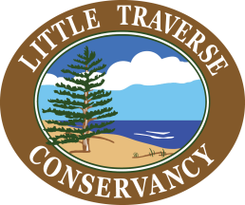

**GROOMED TRAILS**

**2022-23**

*\*Preserves with an asterisk are groomed and tracked for XC skiing on Thursdays or Fridays when conditions allow. All others are just packed when conditions allow.*

Charlevoix County

The Hill

Susan Creek

Rogers Family Homestead

Cheboygan County

Boyd B. Banwell*\**

Chaboiganing & Indian Point*

Emmet County

Goodhart Farms*\**

Allan & Virginia McCune

Offield Family Working Forest

Offield Family Viewlands

**PLOWED PARKING AREAS**

**Winter 2022-23**

Charlevoix County

Charles A. Ransom

Elizabeth B. Hoffmann (Vratanina Rd)

Nathan “Barry” Driggers

Rogers Family Homestead (Erie St.)

Susan Creek

The Hill (Clute Rd)

Taylor Horton Creek

Cheboygan County

Agnes S. Andreae

Boyd B. Banwell (M68)

Duncan Bay

Seven Springs

Chippewa County

Clyde & Martha Williams, Drummond Island

Round Island Point (West Winding Ridge Rd.)

Emmet County

Allan & Virginia McCune (Berger Rd. & Maxwell Rd)

Sally & Art Hailand Jr. and Helstrom Family

Bubbling Springs

Goodhart Farms (Robinson Rd.)

Hoogland Family

Offield Family Viewlands (Upper, Lower)

Offield Family Working Forest (Quick Rd.)

Round Lake

Tanton Family Working Forest

Watson Family & Joseph J. Schott

Elmer Johnston

Seberon “Boo” Litzenburger

Mackinac County

Oliver & Edna Birge (Search Bay & Wheel Rd. trailheads)

William B. Derby